# SEAD Clearing House automatic tests using PHPUnit

## Pre-requisites

PHPUnit must installed on client computer and can be downloaded at http://phpunit.de/.

A getting started guide for PHPUnit can be found at <http://phpunit.de/getting-started.html>.

The guide uses PHPUnit on the MS Windows operating system, but can easily be adapted to Linux using different file paths.

This guide uses the XAMPP Apache distribution that contains, among other things, Apache and PHP. PHPUnit is installed in the same directory as XAMPP PHP.

## NetBeans settings

Several guides exist on the Internet about setting up NetBeans for PHPUnit. NB has built in support for creating, maintaining and running unit tests with PHPUnit.

The paths to PHPUnit executables must be specified in the “Tools – Options – PHP – PHPUnit” settings. The example below uses phpunit found in the xamp\php directory. The skeleton generator script is used when skeleton unit tests are created using a menu item in NetBeans.

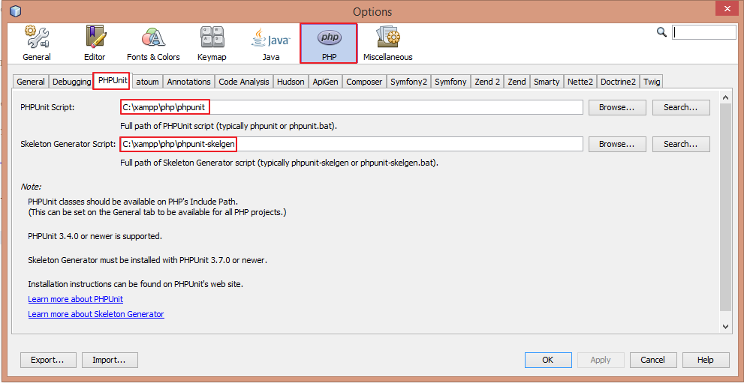

## Project settings

The “Use Bootstrap for Creating New Unit Tests” needs to be ticked in the project property pages as shown below.

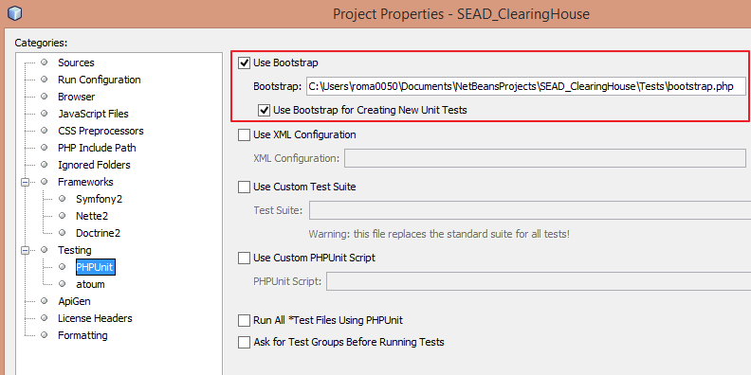

The bootstrap file initializes the test environment. Currently the composer class auto loader feature is loaded since it is needed in order to create new test cases in the IDE (specifically to auto load any classes referenced by the subject under test).

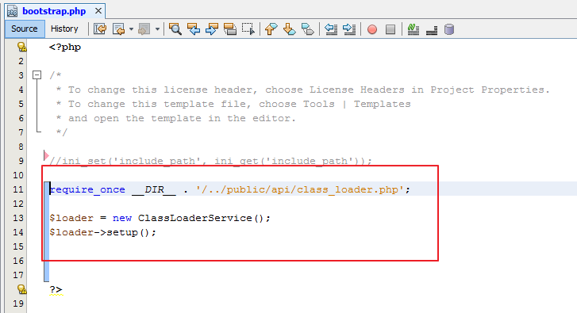

## Location of Unit Tests

Unit tests are stored in The “Tests” folder.

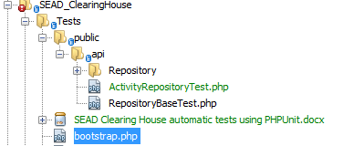

## Create Unit test for specific class

To create a unit test from the IDE